2025 Johnston County 4-H Heifer
Record Book
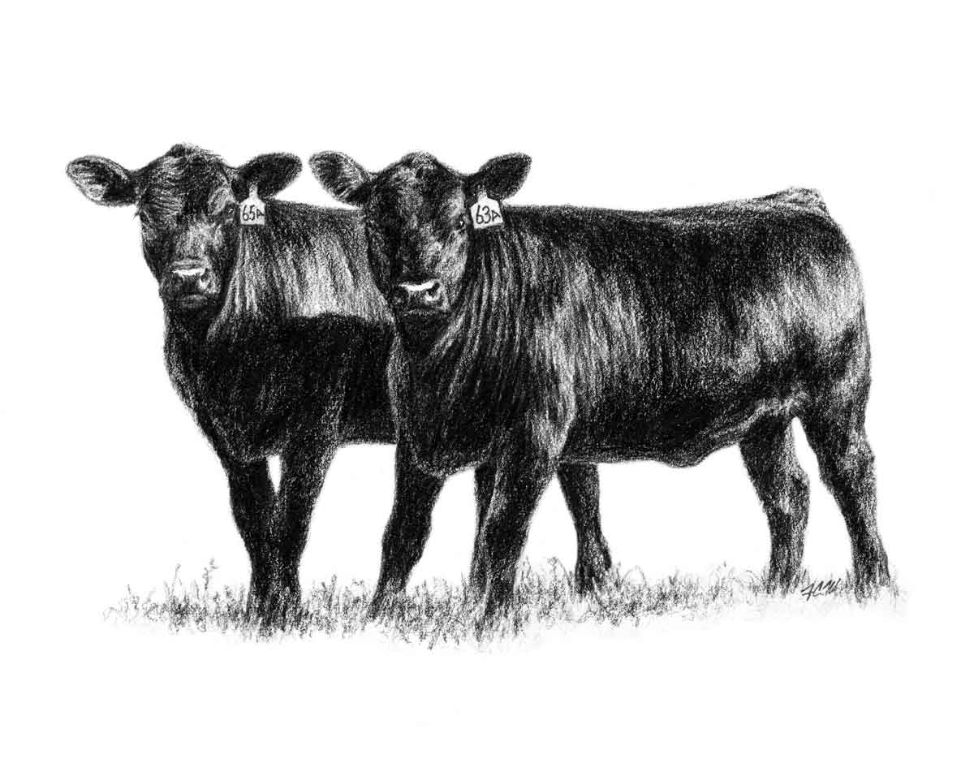

Name:_____________________________________ Birth Date:__________________

Address:_______________________________________________________________

Town:________________________ Zip:_________ Grade in School: ____________

Parents'/ Guardians' Names:_______________________________________________

4H Member:_____ Club Name:__________________________________________

FFA Member:_____ School Name:________________________________________

Leader's Signature:_____________________________________________________________

Agent's Signature:_____________________________________________________________
References:
This record is required for participants in the Johnston County 4-H Heifer
Project. This record must be complete and turned in at the completion of the Youth Livestock Show and Sale project.
Johnston County 4-H Heifer Project Guide
Beef Showmanship factsheet
All publications are available at the Johnston County Cooperative Extension Center

Employment and program opportunities are offered to all people regardless of race, color, national origin, sex, age, or disability. North Carolina State University, North Carolina A&T State University, U.S. Department of Agriculture, and local governments cooperate
Heifer Knowledge
1. At what age do most beef producers wean their calves? ______________________________
2. Weight gained per pound of feed fed is what? _________________________________
3. What do Continental calves typically weigh at 7 months of age? _______________________
4. True or False: A feminine appearance typically indicates reproductive efficiency? _____________________________
5. What percent of expected mature weight should a heifer be when bred? __________________
6. Minerals and salt should be provided on a ______________ basis.
7. Name a clostridial disease that affects cattle. ________________________________________
8. How do you control internal parasites? ___________________________
9. What is a dam? ___________________________________ 10. True or False: Cattle are ruminants. ______________________

Feed & Hay Record
Feed Type | % Protein | Pounds | Cost
Home mix, purchased, etc. | 18%, 16%, 14%, etc. | 200 lbs | $48.00
 |  | Total Weight | Total Cost

Time with your Project
You may wish to estimate hours per day or week to create a total for each item.
Hours Spent General Care (Feeding/Watering)
Hours spent working with project (Walking. Setting Up, etc.)
Hours spent preparing for show (Clipping, Washing, Fitting)
Hours spent on other tasks
Total hours spent with project
Heifer Record
Date purchased |  | Weight
Tattoo/Tag Number |  | Cost
Breeder Name

Misc. Expenses
Item | Cost
Minerals, Salt, Other Feeds not listed in Feed & Hay Record
Veterinary- Vaccines, Dewormer, Vet Visit
Entry fees, Trucking Costs, Show Supplies
Total

Final Record
1.Date Project Started
2.Date Project Ended
3. Final Weight
4. Starting Weight
5. Weight Gain (3-4)
6. Number of days on feed (2-1)
7. Average Daily Gain (Divide 5 by 6)
8. Total Pounds of Feed
9. Feed per lb. of gain (FE) (Divide 8 by 5)
10. Cost of Heifer (from table above)
11. Cost of Feed
12. Cost of misc. (from table above)
13. Total Costs (10+11+12)
14. Premiums won.
15. Other income from heifer (sale, lease, etc.)
16. Total heifer income.
17. Profit or loss (16 – 13)
Placing of Heifer | Tag # | Placing

Project Evaluation
Animals Shown  Check all that apply | Steer | Heifer | Mkt Hog | Mkt Lamb | Mkt Goat | Yrs. In Show

For each question below, place a check mark for your best answer.
 | On my own | With my parent’s help | My parents did this
I fed my animal
I trained my animal
I wrote letters to my buyers

 | Yes | No
I helped with 2 livestock fundraisers (Festival Meal and Ham & Yam)
I am in a 4-H club
If yes, my club had one or more programs on livestock
If yes, I presented a program about livestock to the club
If no, I want to be in a 4-H club
If no, my parents want to be 4-H leaders
I participated in the judging contest at the show
I participate in out-of-county shows (State Fair, Circuit, etc.)

Story
Write a story about your project. Include any unusual event, any learning experience and what you would like to achieve with your livestock project. Include what you want to learn next year. Attach additional sheets, if necessary.

