The Best Valentine's Day for Your Lawn: Pre-emergent

by Carolyn Peterson

Extension Master Gardener Johnston County

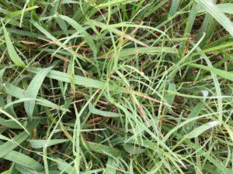

Crabgrass (*Digitaria sanguinalis*) in Bermuda grass. (Photo: Shawn Banks, <https://carteret.ces.ncsu.edu>)

In February, gardeners might dream of the great growing season ahead, but weed seeds are under the surface of the soil or turf, just waiting to leap into action as the weather warms up.

How can we prevent crabgrass and other weeds originating from seeds from sprouting in our lawn? In early spring before seeds germinate, a pre-emergentherbicide can be applied to kill crabgrass and broadleaf weeds. Pre-emergent herbicides kill weed seeds while they germinate by attacking root formation. NC State Extension Specialist Dr. Fred Yelverton recommends that for central NC a pre-emergent be applied between mid-February to the end of February.

A weed’s life cycle has great impact on the selection and success of a given control procedure, so it is important to learn the life cycle characteristics of a weed when you first learn its identity.

Annual weeds germinate from seeds, grow, flower, produce seeds, and die in 12 months or less. Annual weeds are further categorized by the season in which they germinate and flourish. Winter annuals sprout in the fall, thrive during the winter, and die in late spring or early summer. Summer or warm-season grasses, such as crabgrass, sprout in the spring and thrive in summer and early fall.

Common summer annual weeds include crabgrass, foxtail, marestail, purslane, pigweed, lambsquarters, spotted spurge, black medic, and yellow woodsorrel.

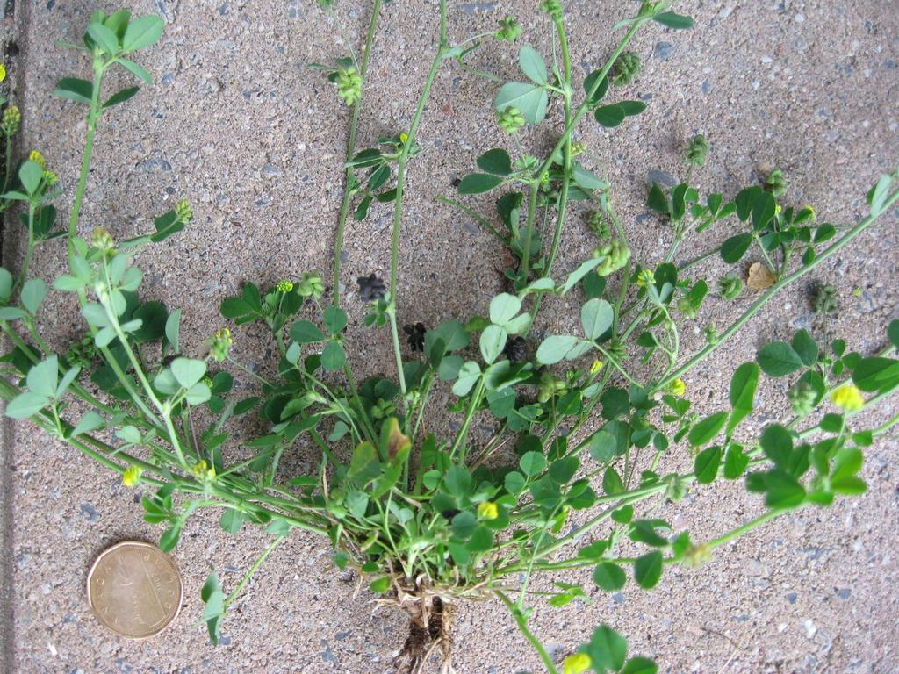

Black medic (*Medicago lupulina) (Photo:* [*https://plants.ces.ncsu.edu/plants/medicago-lupulina/*](https://plants.ces.ncsu.edu/plants/medicago-lupulina/)*)*

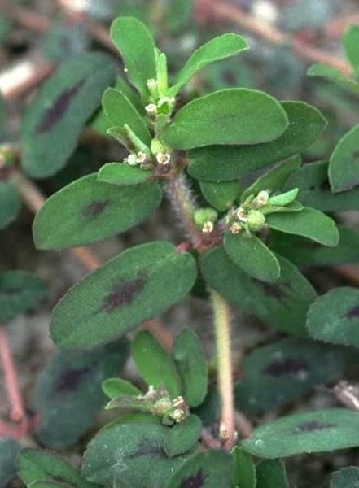

Spotted Spurge (*Euphorbia maculata) (Photo J. Neal,* [*https://plants.ces.ncsu.edu/plants/euphorbia-maculata/*](https://plants.ces.ncsu.edu/plants/euphorbia-maculata/)*)*

IPM stands for "integrated pest management." It is a way to manage insects, diseases, weeds, and animals that can cause damage to your garden or landscape. It uses steps to understand pests and decide the best way to control them. When we use IPM we want to reduce environmental, health and economic risks.

For weed management in your lawn, follow the following steps:

1. **Identify the weed** and understand its lifecycle and how it spreads. For example, dogfennel and crabgrass can reproduce from both seed and roots left in the ground, while nutsedge produces tubers connected to rhizomes, and nutsedge can regrow from nutlets left in the soil after hand pulling.
2. **Prevent or limit damage**. Think of methods to prevent the weeds from invading your lawn, such as preemergent and post emergent herbicide treatments, proper fertilization, watering, and cutting height for the kind of grass in your lawn. A thick healthy lawn may crowd out weeds from entering.
3. **Scout for weeds and pests.** Regularly check your lawn for the appearance of new weeds and other pests and consider keeping a journal to record what you find to plan management of the weed.
4. **Implement your control tactics and evaluate the outcome**. Hand-pulling weeds may work for limited populations of weeds in your lawn, but use of pre-emergent and post-emergent herbicides would be required for widespread problems. If using herbicides, always follow label instructions to protect yourself and the environment.

When you purchase a spring pre-emergent herbicide (crabgrass control product), it usually is a granular product to be applied by a broadcast speader or drop spreader. Be sure to read the label to verify that it is safe to use on your type of grass. The label will also tell you what other weeds the product can control and advise how much to apply and when to water the lawn.

Many weeds can also be discouraged by proper cultivation practices. Crabgrass and other weeds like to grow in thin turf. Fertilize your lawn and irrigate only once or twice a week. If you irrigate every day, the crabgrass will love the extra water and will grow faster, well, like a weed!

Sources:

<https://www.turffiles.ncsu.edu/2024/02/when-to-apply-preemergent-herbicides-for-turfgrasses/>

<https://carteret.ces.ncsu.edu/2020/04/controlling-crabgrass-in-your-yard/>

<https://content.ces.ncsu.edu/extension-gardener-handbook/6-weeds>

<https://hgic.clemson.edu/factsheet/broadleaf-weeds/>

<https://www.turffiles.ncsu.edu/weeds-in-turf/>

<https://hgic.clemson.edu/factsheet/managing-weeds-in-warm-season-lawns/>

[How to calibrate your spreader for proper preemergence and fertilizer applications](https://johnston.ces.ncsu.edu/wp-content/uploads/2024/12/Spreader-calibration-Tim-B.pdf)