2022 Johnston County

4-H Market Goat

Record Book

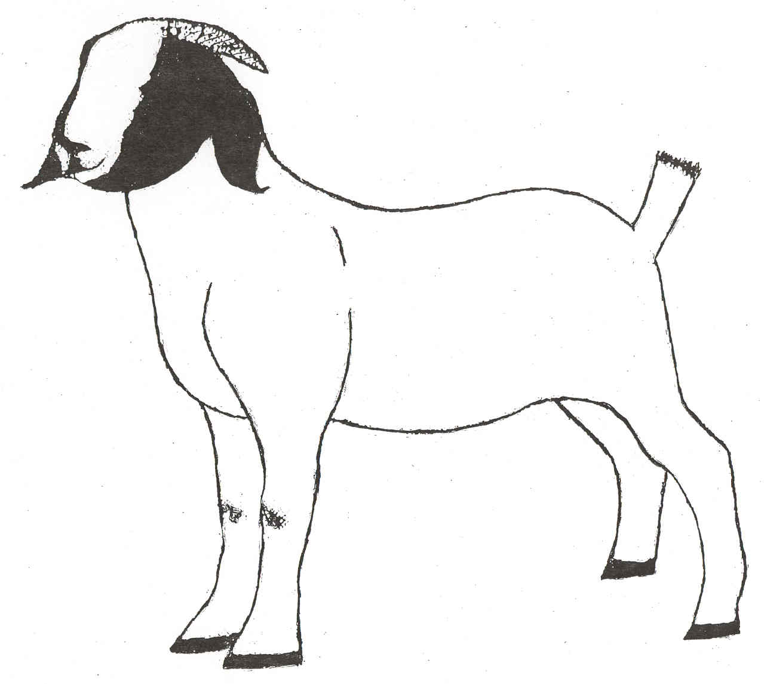

Name:_____________________________________ Birth Date: _________________

Address: ______________________________________________________________

Town:______________________ Zip:__________ Grade in School:______________

Parents'/ Guardians' Names:_______________________________________________

4H Member:_____ Club Name:_________________________________________

FFA Member:_____ School Name:_______________________________________

Leader's Signature:_____________________________________________________________

Agent's Signature:_____________________________________________________________

References:

This record is required for participants in the Johnston County 4-H Market Goat project. This record must be completed and submitted at the conclusion of the Youth Livestock Show & Sale.

4-H Meat Goat Guide, (Project Book)

All publications are available at the Johnston County Cooperative Extension Center



Employment and program opportunities are offered to all people regardless of race, color, national origin, sex, age, or disability. North

Carolina State University, North Carolina A&T State University, U.S. Department of Agriculture, and local governments cooperating.

Goat Knowledge (All answers can be found in the project book)

1. To keep goats from jumping out, how high should a fence be? __________________________

2. How high should a feeding trough be placed? __________________________

3. What disease is called overeating disease? __________________________

4. True or False? Fresh water is the most important feeding ingredient. ____________________

5. True or False? A wide standing goat is a light muscled goat. ____________________

6. Name a goat body part. (Different than last year) _________________________

Feed & Hay Record

|  |  |  |  |
| --- | --- | --- | --- |
| Feed Type | % Protein | Pounds | Cost |
| *Home mix, purchased, etc.* | *18%, 16%, 14%, etc.* | *200 lbs* | *$48.00* |
|  |  |  |  |
|  |  |  |  |
|  |  |  |  |
|  |  |  |  |
|  |  |  |  |
|  |  |  |  |
|  | | **Total Weight** | **Total Cost** |
|  |  |

Time with your Project

You may wish to estimate hours per day or week to create a total for each item.

|  |  |
| --- | --- |
| Hours Spent General Care (Feeding/Watering) |  |
| Hours spent working with project (Walking. Setting Up, etc.) |  |
| Hours spent preparing for show (Clipping, Washing, Fitting) |  |
| Hours spent on other tasks |  |
| Total hours spent with project |  |

Goat Record

|  |  |  |  |  |
| --- | --- | --- | --- | --- |
| Tag # | Date purchased | Breeder | Weight | Cost |
|  |  |  |  |  |
|  |  |  |  |  |
|  | | | **Total** |  |

Misc. Expenses

|  |  |
| --- | --- |
| Item | Cost |
| Minerals, Salt, Other Feeds not listed in Feed & Hay Record |  |
| Veterinary- Vaccines, Dewormer, Vet Visit |  |
| Entry fees, Trucking Costs, Show Supplies |  |
| **Total** |  |

Final Record

|  |  |  |  |  |  |  |  |  |
| --- | --- | --- | --- | --- | --- | --- | --- | --- |
| 1.Date Project Started | | | | | | | |  |
| 2.Date Project Ended | | | | | | | |  |
| 3. Final Weight | Tag # | | Weight | | Tag # | | Weight | Total  (Both Goats) |
|  | |  | |  | |  |  |
| 4. Starting Weight | | |  | |  | |  | Total |
|  |
| 5. Weight Gain (3-4) | | |  | |  | Total |
|  |
| 6. Number of days on feed (2-1) | | | | | | | |  |
| 7. Average Daily Gain  (Divide 5 by 6) | | | ADG | |  | | ADG | Total ADG |
|  | |  |  |
| 8. Total Pounds of Feed  (Divide in half if 2 goats) | | | Lbs | | Lbs | Total |
|  | |  |  |
| 9. Feed per lb. of gain (FE)  (Divide 8 by 5) | | | FE | | FE | Average |
|  | |  |  |
| 10. Cost of Goats  (from table on page 2) | | | Cost | | Cost | Total |
|  | |  |  |
| 11. Cost of Feed  (Divide in half if 2 goats) | | |  | |  | Total |
|  |
| 12. Cost of misc.  (from table above) | | |  | |  | Total |
|  |
| 13. Total Costs (10+11+12) | | |  | |  | Total |
|  |
| 14a. Packer Price for first goat ($0 if not sold to packer) | | | | | | | |  |
| 14b. Packer Price for second goat ($0 if not sold to packer) | | | | | | | |  |
| 14c. Sponsor Price received in sale | | | | | | | |  |
| 15. Total goat income (14a+14b+14c) | | | | | | | |  |
| 16. Profit or loss (15 – 13) | | | | | | | |  |
| Placing of Goat | | Tag # | | Placing | | Tag # | | Placing |
|  | |  | |  | |  |

Project Evaluation

|  |  |  |  |  |  |  |
| --- | --- | --- | --- | --- | --- | --- |
| Animals Shown  Check all that apply | Steer | Heifer | Mkt Hog | Mkt Lamb | Mkt Goat | Yrs. In Show |
|  |  |  |  |  |  |

For each question below, place a check mark for your best answer.

|  |  |  |  |
| --- | --- | --- | --- |
|  | On my own | With my parent’s help | My parents did this |
| I fed my animal |  |  |  |
| I trained my animal |  |  |  |
| I wrote letters to my buyers |  |  |  |

|  |  |  |
| --- | --- | --- |
|  | Yes | No |
| I helped with the livestock fundraiser (Festival Supper in November) |  |  |
| I am in a 4-H club |  |  |
| If yes, my club had one or more programs on livestock |  |  |
| If yes, I presented a program about livestock to the club |  |  |
| If no, I want to be in a 4-H club |  |  |
| If no, my parents want to be 4-H leaders |  |  |
| I participated in the judging contest at the show |  |  |
| I participate in out-of-county shows (State Fair, Circuit, etc.) |  |  |

Story

Write a story about your project. Include any unusual event, any learning experience and what you would like to achieve with your livestock project. Include what you want to learn next year. Attach additional sheets, if necessary.