Johnston County

4-H Market Goat

Revised Record Book 2020

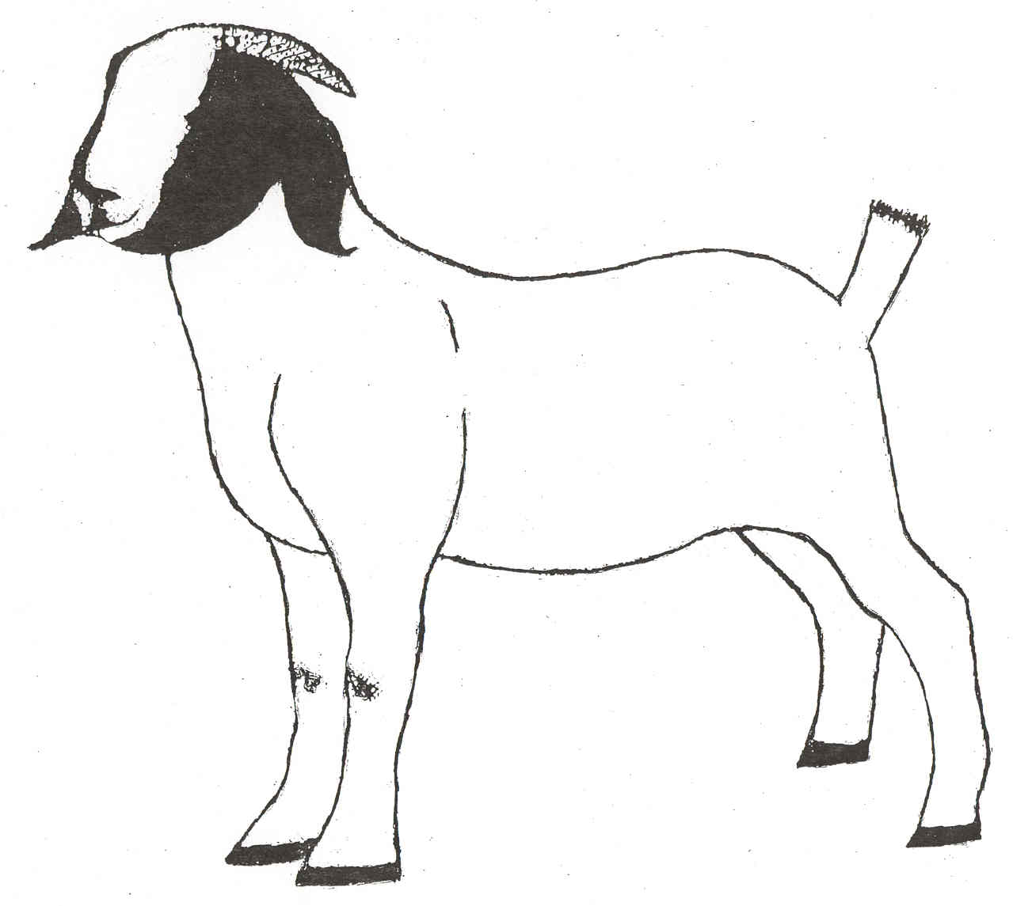

Name:_____________________________________ Birth Date: _________________

Address: ______________________________________________________________

Town:______________________ Zip:__________ Grade in School:______________

Parents'/ Guardians' Names:_______________________________________________

4H Member:_____ Club Name:_________________________________________

FFA Member:_____ School Name:_______________________________________

Leader's Signature:_____________________________________________________________

Agent's Signature:_____________________________________________________________

References:

This record is required for participants in the Johnston County 4-H Market Goat project. This record must be completed and submitted at the conclusion of the Youth Livestock Show & Sale.

4-H Meat Goat Guide, (Project Book)

All publications are available at the Johnston County Cooperative Extension Center



Employment and program opportunities are offered to all people regardless of race, color, national origin, sex, age, or disability. North

Carolina State University, North Carolina A&T State University, U.S. Department of Agriculture, and local governments cooperating.

Project Record

I purchased my animal(s) from(breeder)_____________________________on (date)_________. It (they) weighed (tag or id # &weight) ________________________. I began feeding it (them) on (date)_________and tagging took place (date)__________. I weighed it (them) several more times and the weights were (tag, date & weight) _____________________________________________________________________. Deworming took place (date)__________ using (product)_______________________. The dewormer has a withdrawal time of _______________. My animal became sick (yes or no) and was treated with (date & product) ____________________. This product has a withdrawal time of_______________. I trimmed my animal(s) hooves on (date.)____________.

Did you show your goat at any early shows Yes/No If yes, placing was ­­­­­­­_____________________

Did you participate in the Virtual Livestock Show? Yes/No If yes, results: __________________

______________________________________________________________________________

Goat Knowledge (All answers can be found in the project book)

1. When selecting a goat what does structural correctness mean? _________________________
2. What minerals are needed for proper goat growth and development? ____________________
3. What disease causes weight loss and inefficiency in goats? ____________________________
4. True or False? Exercise is good for you and your goat. _______________________________
5. True or False? It is a good idea to wear a hat into the show ring. ________________________

6. Name a goat body part. (Different from last year) __________________

Feed & Hay Record

|  |  |  |  |
| --- | --- | --- | --- |
| Feed Type | % Protein | Pounds | Cost |
| *Home mix, purchased, etc.* | *18%, 16%, 14%, etc.* | *200 lbs* | *$48.00* |
|  |  |  |  |
|  |  |  |  |
|  |  |  |  |
|  |  |  |  |
|  | | **Total Weight** | **Total Cost** |
|  |  |

Goat Record

|  |  |  |  |
| --- | --- | --- | --- |
| Date | Goat Number | Weight | Cost |
|  |  |  |  |
|  |  |  |  |
|  | | **Total** |  |

Misc. Expenses (List) Attach additional sheets if needed

(Veterinary Costs, Medications, Pen Materials, Fencing Materials, Etc.)

|  |  |
| --- | --- |
| Item | Cost |
|  |  |
|  |  |
|  |  |
| **Total** |  |

Final Record

|  |  |  |  |  |  |
| --- | --- | --- | --- | --- | --- |
| 1.Date Project Started | | | | |  |
| 2.Date Project Ended | | | | |  |
| 3. Final Weight | Tag # | Weight | Tag # | Weight | Total  (Both Goats) |
|  |  |  |  |  |
| 4. Starting Weight | |  |  |  | Total |
|  |
| 5. Weight Gain (3-4) | |  |  | Total |
|  |
| 6. Number of days on feed (2-1) | | | | |  |
| 7. Average Daily Gain  (Divide 5 by 6) | | ADG |  | ADG | Total ADG |
|  |  |  |
| 8. Total Pounds of Feed  (Divide in half if 2 goats) | | Lbs | Lbs | Total |
|  |  |  |
| 9. Feed per lb. of gain (FE)  (Divide 8 by 5) | | FE | FE | Average |
|  |  |  |
| 10. Cost of Goats  (from table on page 2) | | Cost | Cost | Total |
|  |  |  |
| 11. Cost of Feed  (Divide in half if 2 goats) | |  |  | Total |
|  |
| 12. Cost of misc.  (from table above) | |  |  | Total |
|  |
| 13. Total Costs (10+11+12) | |  |  | Total |
|  |
| 14a. Packer Price for first goat (if sold) | | | | |  |
| 14b. Packer Price for second goat (if sold) | | | | |  |
| 14c. Sponsor Price received from supporters | | | | |  |
| 15. Total goat income (14a+14b+14c) | | | | |  |
| 16. Profit or loss (15 – 13) | | | | |  |

Project Evaluation

|  |  |  |  |  |  |  |
| --- | --- | --- | --- | --- | --- | --- |
| Animals Shown  Check all that apply | Steer | Heifer | Mkt Hog | Mkt Lamb | Mkt Goat | Yrs. In Show |
|  |  |  |  |  |  |

For each question below, place a check mark for your best answer.

|  |  |  |  |
| --- | --- | --- | --- |
|  | On my own | With my parent’s help | My parents did this |
| I fed my animal |  |  |  |
| I trained my animal |  |  |  |
| I wrote letters to my buyers |  |  |  |

|  |  |  |
| --- | --- | --- |
|  | Yes | No |
| I helped with youth livestock fundraisers (Festival Meal and Silent Auction) |  |  |
| I am in a 4-H club |  |  |
| If yes, my club had one or more programs on livestock |  |  |
| If yes, I presented a program about livestock to the club |  |  |
| If no, I want to be in a 4-H club |  |  |
| If no, my parents want to be 4-H leaders |  |  |
| I participate in out-of-county shows (State Fair, Circuit, etc.) |  |  |

Story

Write a story about your project. Include any unusual event, any learning experience and what you would like to achieve with your livestock project. Include what you want to learn next year. Attach additional sheets, if necessary.